**FINAL PROJECT IOT(2023)**

**BATCH CODE: OV-201911F**

***MEMBERS: • M. Arsalan Sup***

***•M. Nabeel Nadeem***

***• Aman***

* ***Noor Muhammad***

***•Abdul Rafay***

***Abstract***

For the monitoring of radiation, albedo, wind speed, wind direction, air temperature, humidity, module temperature, soiling, and other factors, the WMS employs high-accuracy sensors. We have a large collection of sensors from several international sensor manufacturers.

We are aware that projects of various sizes have unique requirements, and a one-size-fits-all strategy is ineffective. Therefore, before advising you on the sensor combination that is best from both a performance and a financial standpoint, we investigate and evaluate a huge variety of sensors.

For accurate and trustworthy data collecting from the weather sensors, a high-reliability data logger made by Aeron is connected to the sensors. To reduce noise and inaccuracies, the logger applies sophisticated software filters to the data it has recorded. Data is transmitted across wired and wireless means and is kept in the logger.

The data logger includes Ethernet, RS485 MODBUS options for cable transmission to SCADA and RTU, as well as 4G and Wi-Fi for wireless data communication. From KW to MW in size, Aeron offers a selection of data loggers and gateways ideal for your project.

**•Introduction**

This program's goal is to provide a sample project so that participants can work on actual tasks. These programs assist you in creating a bigger, more capable program.

The goal is to give you a real-life scenario and assist you in using the tools to construct simple apps rather than teaching you about the Internet of Things (IoT).

Before beginning the project, you can edit the chapters.

Students who have finished the IoT module (Hardware and Network) are intended for this assignment. These program ought to be carried out during lab sessions, possibly with academic support.

A student must have a firm grasp of the subject, which is crucial.

**•Purpose**

These days, the weather forecast is unpredictable and unreliable due to the fast changing climate. Consequently, the Meteorological Reporting System is mostly used to keep an eye on the continuously changing climatic and weather conditions in overly regulated regions like houses, businesses, farms, and so forth.

**•Scope of the project**

It measures the air around it using a thermistor and a capacitive humidity sensor, and it outputs a digital value on the data pin (no analogue information pins required). Since this sensor can only provide new information once every two seconds, using our library may result in sensor values that are up to two seconds outdated. The power source ranges from 3 to 5 volts. Good for readings of 20-80% humidity with a 5% accuracy and 0-50°C temperatures with a 2°C accuracy.

**•Problem definition**

Abstract—Temperature variations today frequently have a significant impact on our way of life. For instance, the types of fruits and vegetables that can grow are heavily influenced by temperature and weather fluctuations.

Extreme weather occurrences, such as hurricanes, droughts, fires (including forest fires), floods, heat waves or cold snaps, and winter storms, are another significant part of the weather that significantly impacts our daily life. Weather stations should adapt to the world's rapid change. People like us would always want to have remote access to control and observe the temperature in our surroundings.

Therefore, you are required to keep an eye on the following during this assignment.

Temperature, humidity, air quality, light value, and more.

In the Mongo DB, a log will be kept after every 15 minutes.

•**Objective of the study**

This project focuses on the above problem by introducing dynamic IOT Python. Based weather monitoring system using Raspberry Pi to determine weather.

**SENSORS & PROBES REQUIRED:**

**•GAS SENSOR**

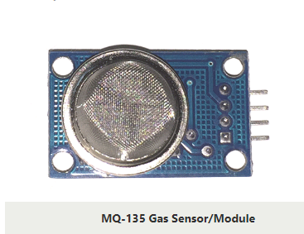

**Description:**

To do this, you can either utilise an analogue pin or a digital pin. Simply apply 5V to the module to start seeing the power LED shine. When no gas is detected, the output LED will remain out, leaving the digital output pin at 0V. Keep in mind that these sensors must be kept on during the pre-heating period (discussed in the features above) before you may use it. The output LED and digital pin should now both go high as you introduce the sensor to the gas you wish to detect; if not, adjust the potentiometer until the output does.

**Specifications:**

* Wide detecting scope
* Fast response and High sensitivity
* Stable and long life
* Operating Voltage is +5V
* Detect/Measure NH3, NOx, alcohol, Benzene, smoke, CO2, etc.
* Analog output voltage: 0V to 5V
* Digital output voltage: 0V or 5V (TTL Logic)
* Preheat duration 20 seconds
* Can be used as a Digital or analog sensor
* The Sensitivity of Digital pin can be varied using the potentiometer

**•TEMPERATURE & HUMIDITY SENSOR**

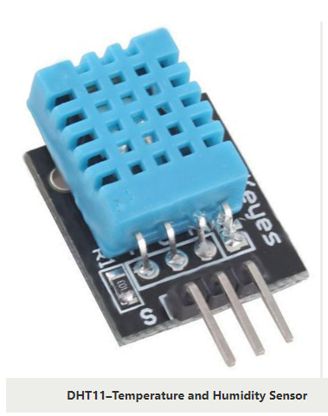

**Description:**

A typical temperature and humidity sensor is the DHT11. The sensor includes a dedicated NTC for temperature measurement and an 8-bit microprocessor for serial data output of temperature and humidity information. Additionally factory calibrated, the sensor makes it simple to integrate with other microcontrollers.

The sensor has an accuracy of 1°C and 1% and can measure temperature from 0°C to 50°C and humidity from 20% to 90%. Therefore, if you want to measure in this range, this sensor might be the best option.

**Specifications:**

* Operating Voltage: 3.5V to 5.5V
* Operating current: 0.3mA (measuring) 60uA (standby)
* Output: Serial data
* Temperature Range: 0°C to 50°C
* Humidity Range: 20% to 90%
* Resolution: Temperature and Humidity both are 16-bit
* Accuracy: ±1°C and ±1%

**•LDR MODULE**

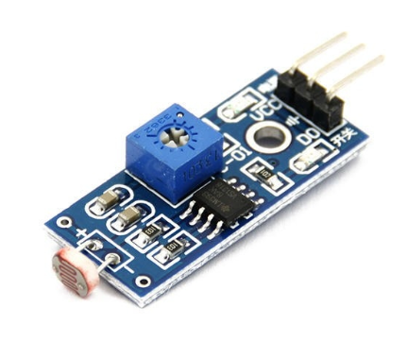

**Description:**

The LDR sensor module is used to measure light intensity. It is connected to the board's analogue output pin (labelled AO) and digital output pin (labelled DO), respectively. LDR resistance decreases with increasing light intensity when there is light. The resistance of LDR decreases as light intensity increases. The potentiometer knob on the sensor can be turned to alter the LDR's sensitivity to light.

**Specifications:**

* Input Voltage: DC 3.3V to 5V
* Output: Analog and Digital
* Sensitivity adjustable

**•TEMPERATURE SENSOR**

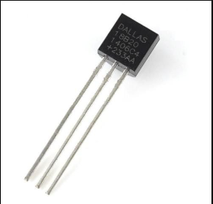

* **Description:**

This is Maxim IC's most recent DS18B20 1-Wire digital temperature sensor. -55C to 125C (+/-0.5C) in degrees C, with 9 to 12-bit precision. With a 64-bit serial number engraved specifically into each sensor, a large number of sensors can be used on a single data bus. This is a fantastic component that serves as the foundation for numerous temperature control and data logging projects.

**• Specifications:**

* Programmable Digital Temperature Sensor
* Communicates using 1-Wire method
* Operating voltage: 3V to 5V
* Temperature Range: -55°C to +125°C
* Accuracy: ±0.5°C
* Output Resolution: 9-bit to 12-bit (programmable)
* Unique 64-bit address enables multiplexing
* Conversion time: 750ms at 12-bit
* Programmable alarm options
* Available as To-92, SOP and even as a waterproof sensor

**•LCD DISPLAY (16x2)**

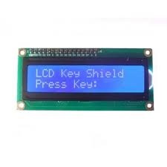

* **Description:**

An LCD (Liquid Crystal Display) screen is an electronic display module and has a wide range of applications. A 16x2 LCD display is very basic module and is very commonly used in various devices and circuits. A 16x2 LCD means it can display 16 characters per line and there are 2 such lines. In this LCD each character is displayed in 5x7 pixel matrix. The 16 x 2 intelligent alphanumeric dot matrix display is capable of displaying 224 different characters and symbols. This LCD has two registers, namely, Command and Data.

**• Specifications:**

* PCB Dimensions: 80mm x 35mm x 11mm
* Screen Dimensions: 64.5mm x 16mm

**•ADS 1115 ATD Converter:**

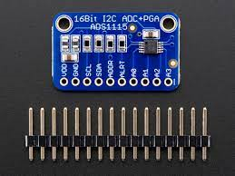

* **Description:**

This converter will of course prove useful to all those not possessing a microcontroller with an analogue-to-digital converter. It can also be added to a pre-existing CAN for taking more precise measurements of small and large signals. Such a device can be used to create a temperature measuring tool, an automation or process control system, or even a battery level indicator. Its tiny size means it can be used in extremely compact portable projects.

**• Specifications:**

* 2 mm × 1.5 mm × 0.4 mm
* Wide Supply Range: 2.0 V to 5.5 V
* Low Current Consumption: 150 μA (Continuous-Conversion Mode)
* Programmable Data Rate: 8 SPS to 860 SPS
* Single-Cycle Settling
* Internal Low-Drift Voltage Reference
* Internal Oscillator
* 2C Interface: Four Pin-Selectable Addresses
* Four Single-Ended or Two Differential Inputs (ADS1115)
* Programmable Comparator (ADS1114 and ADS1115)
* Operating Temperature Range: –40°C to +125°C

**•Raspberry Pi-4**

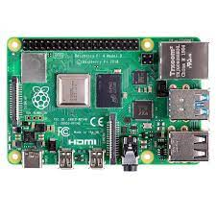

* **Description:**

Raspberry Pi 4 Model B is the latest product in the popular Raspberry Pi range of computers. It offers ground-breaking increases in processor speed, multimedia performance, memory, and connectivity compared to the prior-generation Raspberry Pi 3 Model B+, while retaining backwards compatibility and similar power consumption. For the end user, Raspberry Pi 4 Model B provides desktop performance comparable to entry-level x86 PC systems.

**• Specifications:**

* Broadcom BCM2711, Quad core Cortex-A72 (ARM v8) 64-bit SoC @ 1.5GHz
* 1GB, 2GB, 4GB or 8GB LPDDR4-3200 SDRAM (depending on model)
* 2.4 GHz and 5.0 GHz IEEE 802.11ac wireless, Bluetooth 5.0, BLE
* Gigabit Ethernet
* 2 USB 3.0 ports; 2 USB 2.0 ports.
* Raspberry Pi standard 40 pin GPIO header (fully backwards compatible with previous boards)
* 2 × micro-HDMI ports (up to 4kp60 supported)
* 2-lane MIPI DSI display port
* 2-lane MIPI CSI camera port
* 4-pole stereo audio and composite video port
* H.265 (4kp60 decode), H264 (1080p60 decode, 1080p30 encode)
* OpenGL ES 3.1, Vulkan 1.0
* Micro-SD card slot for loading operating system and data storage
* 5V DC via USB-C connector (minimum 3A*)
* 5V DC via GPIO header (minimum 3A*)
* Power over Ethernet (PoE) enabled (requires separate PoE HAT)
* Operating temperature: 0 – 50 degrees C ambie

***TESTING AND UNDERSTANDING CIRCUITARY***

* **CIRCUIT DIAGRAMS FOR TESTING:**
* **LCD TESTING:**

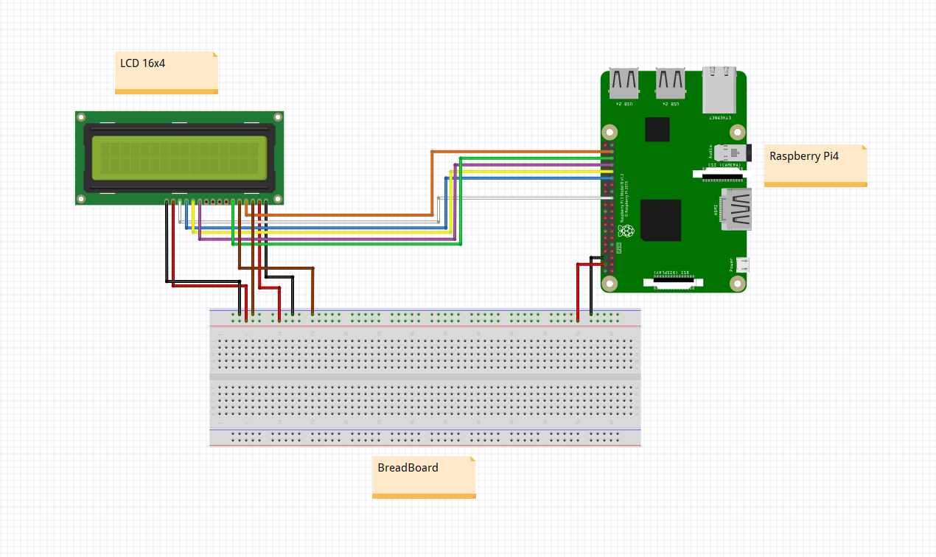

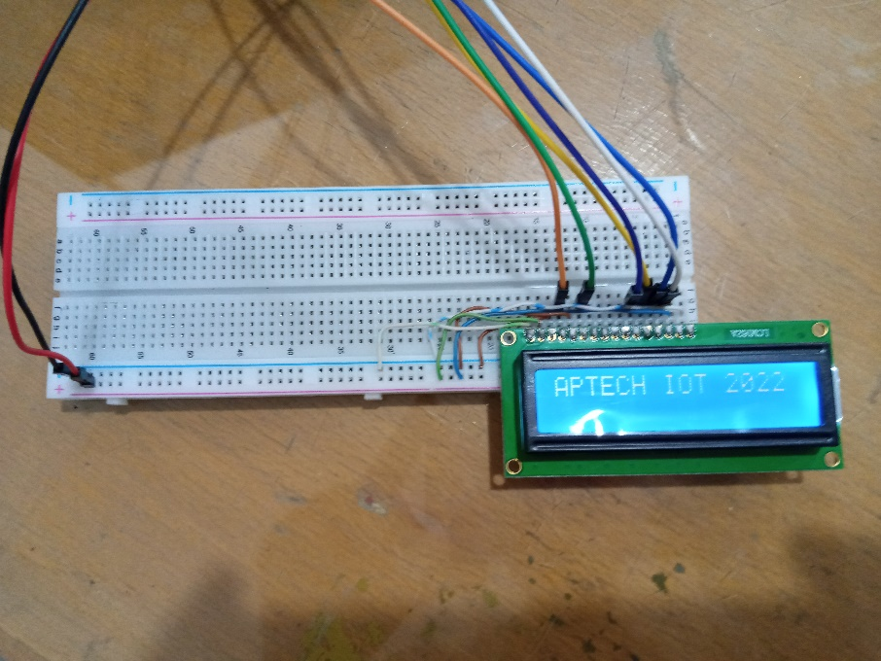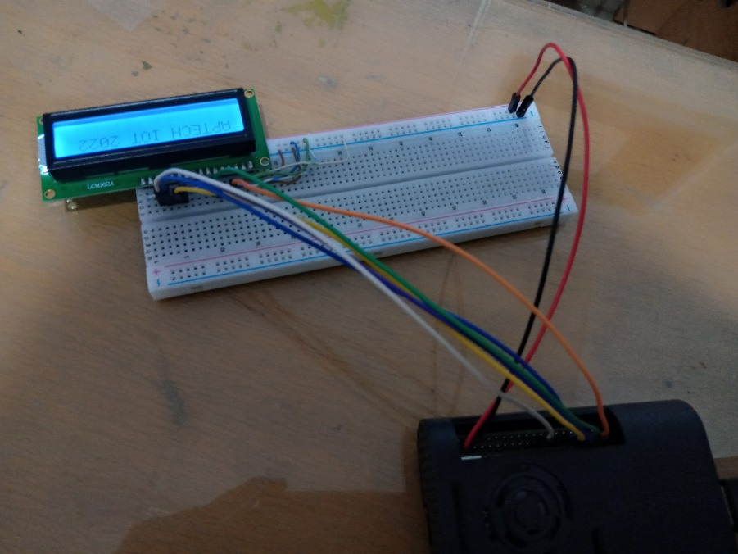

* **PH TESTING:**

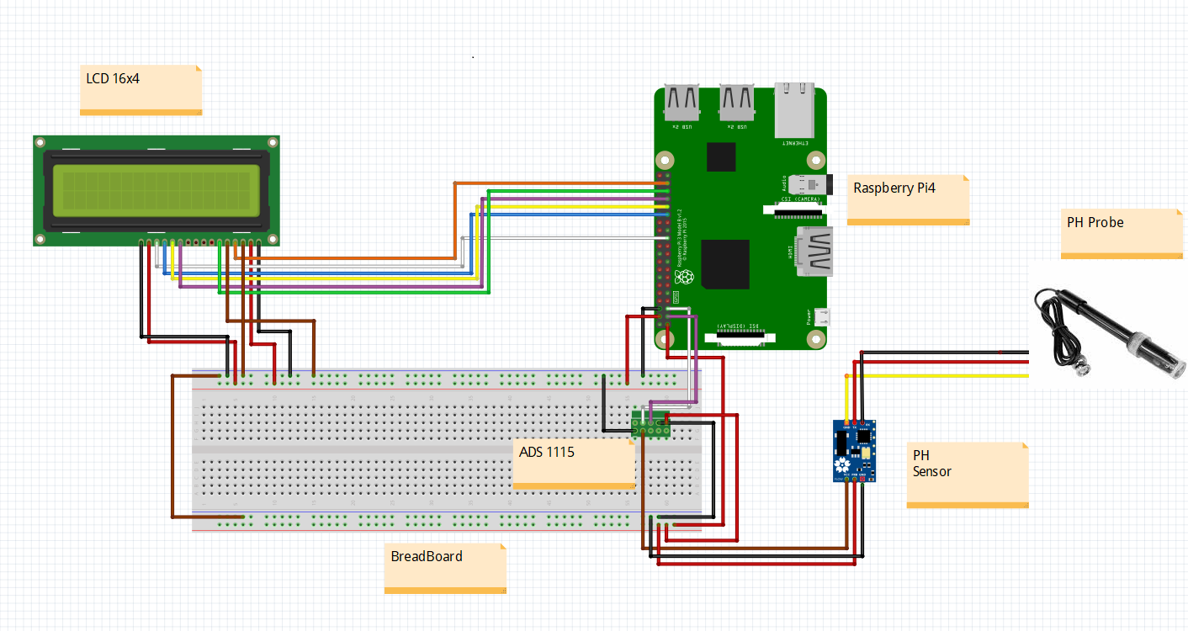

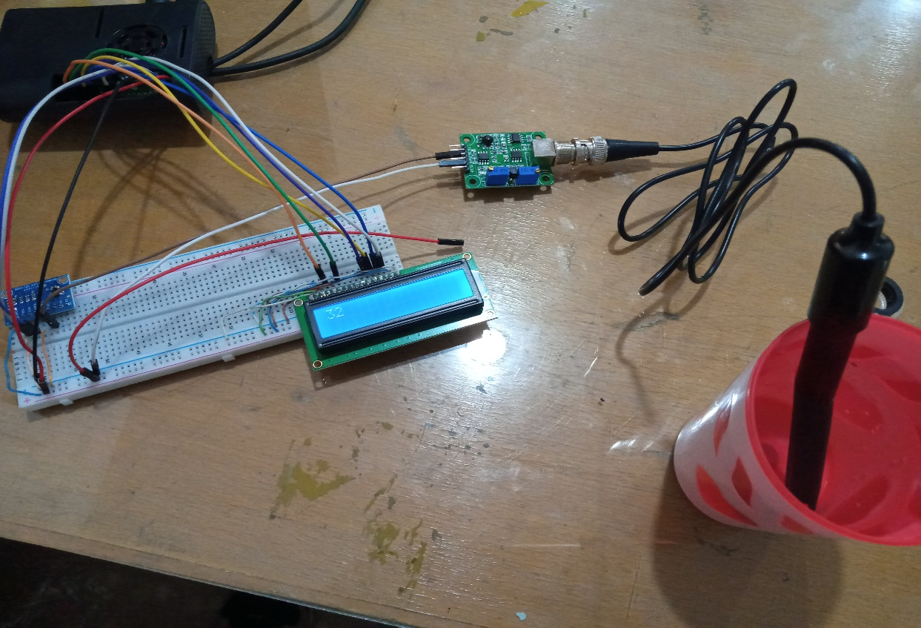

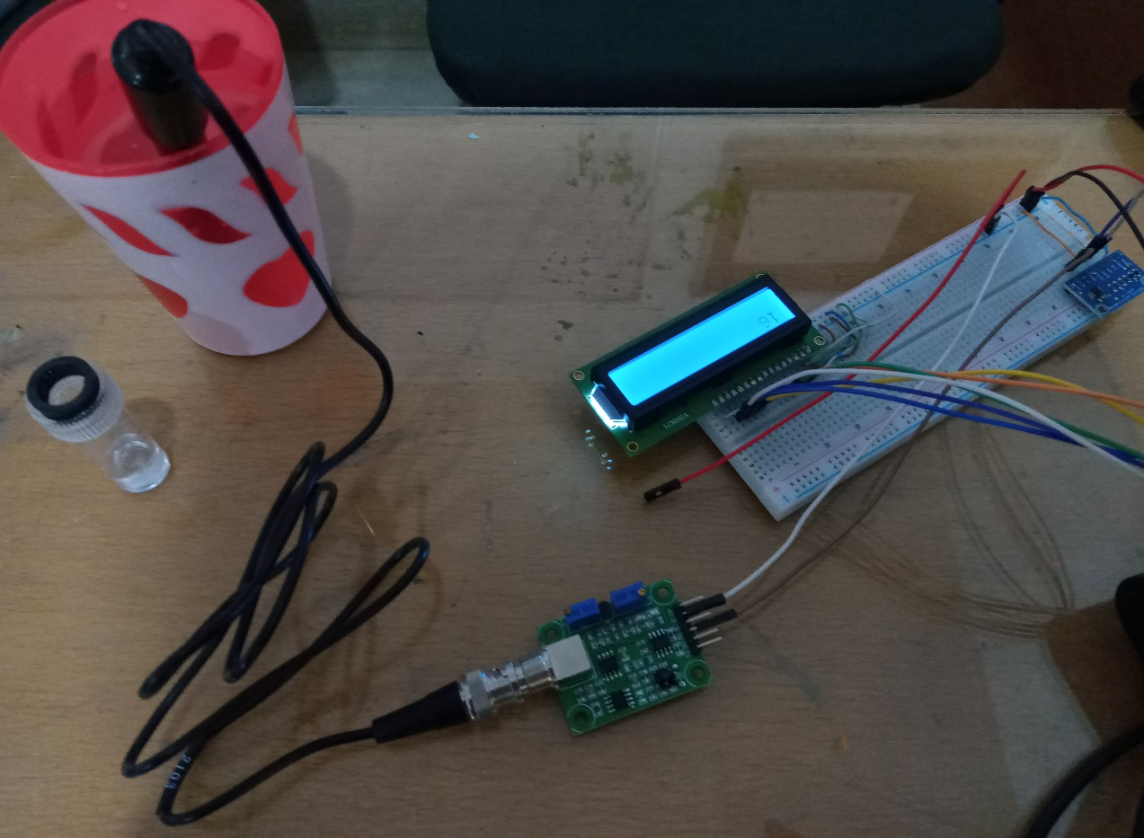

* **WATERFLOW TESTING:**

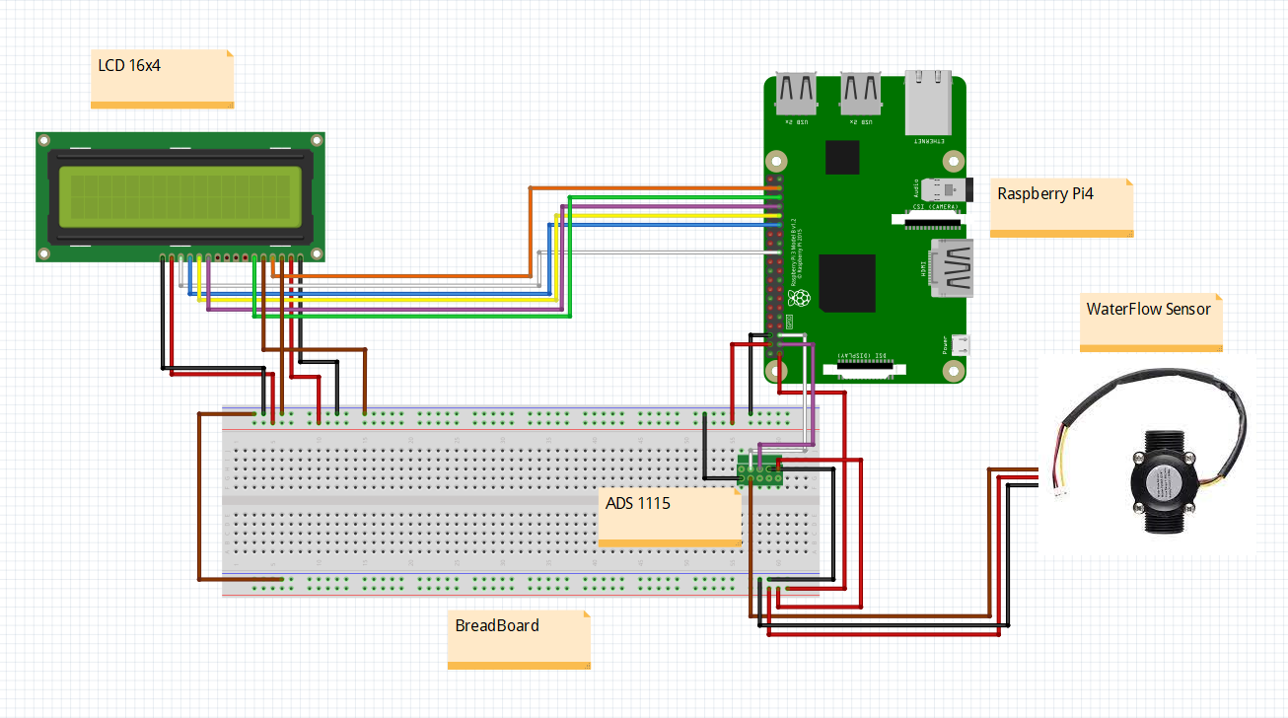

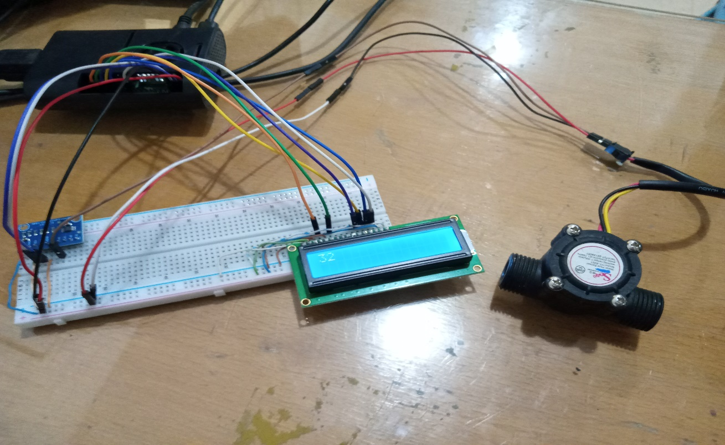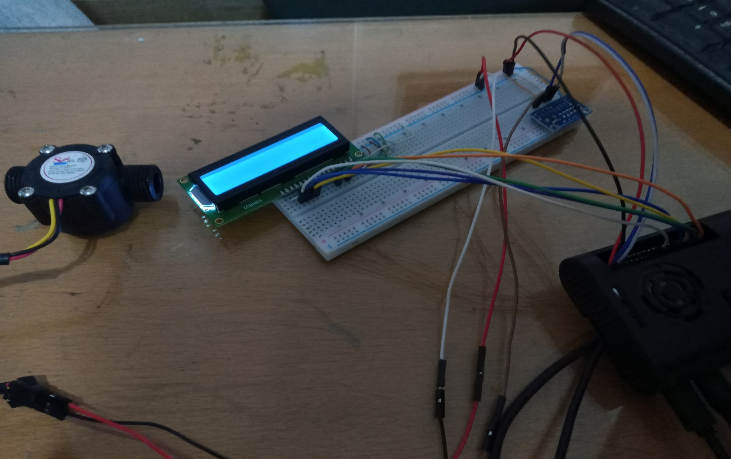

* **TURBIDITY TESTING:**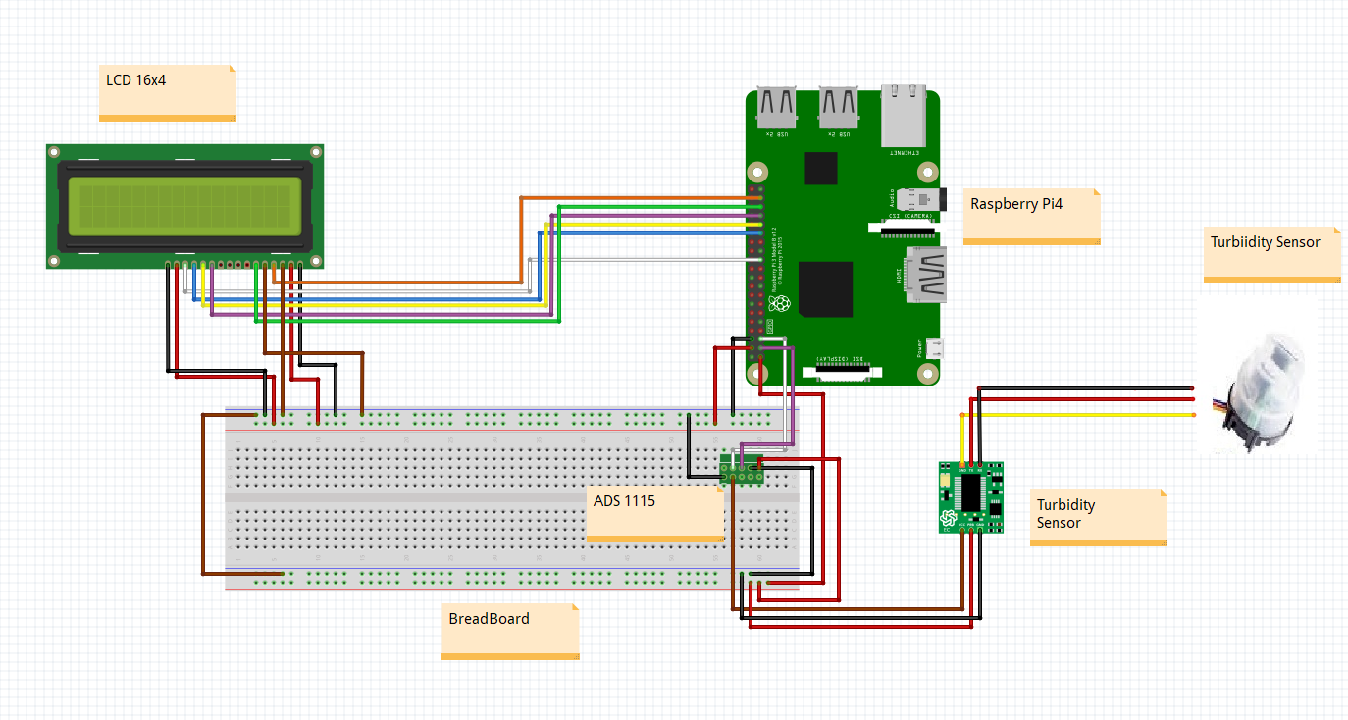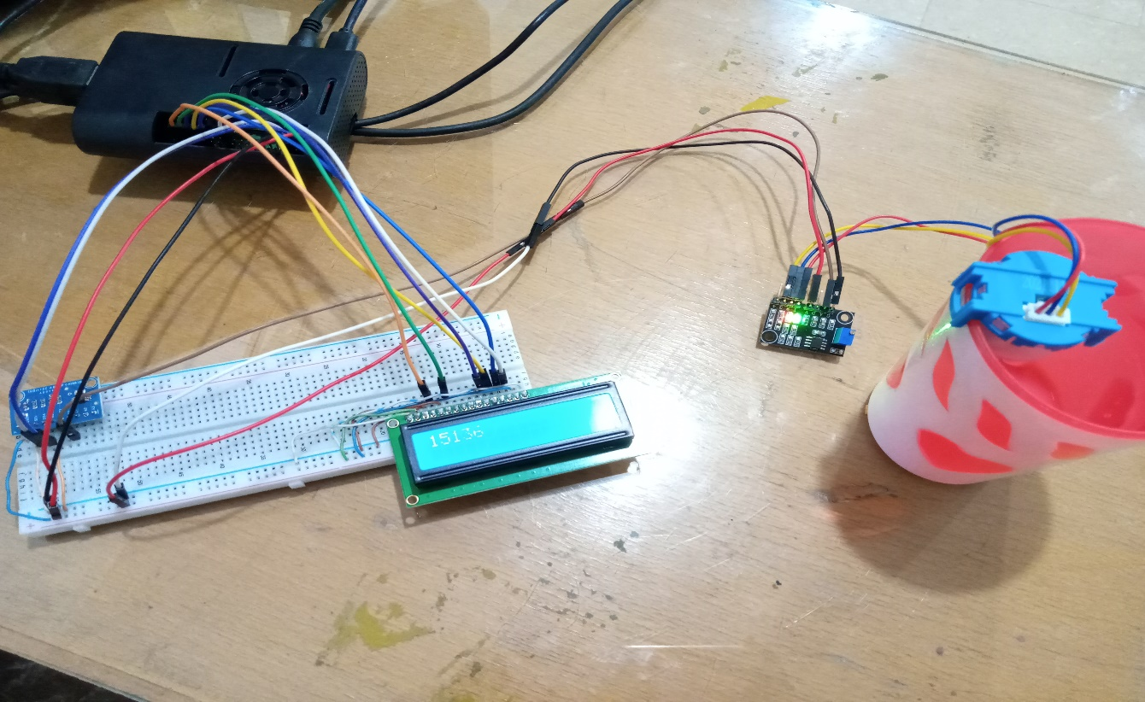

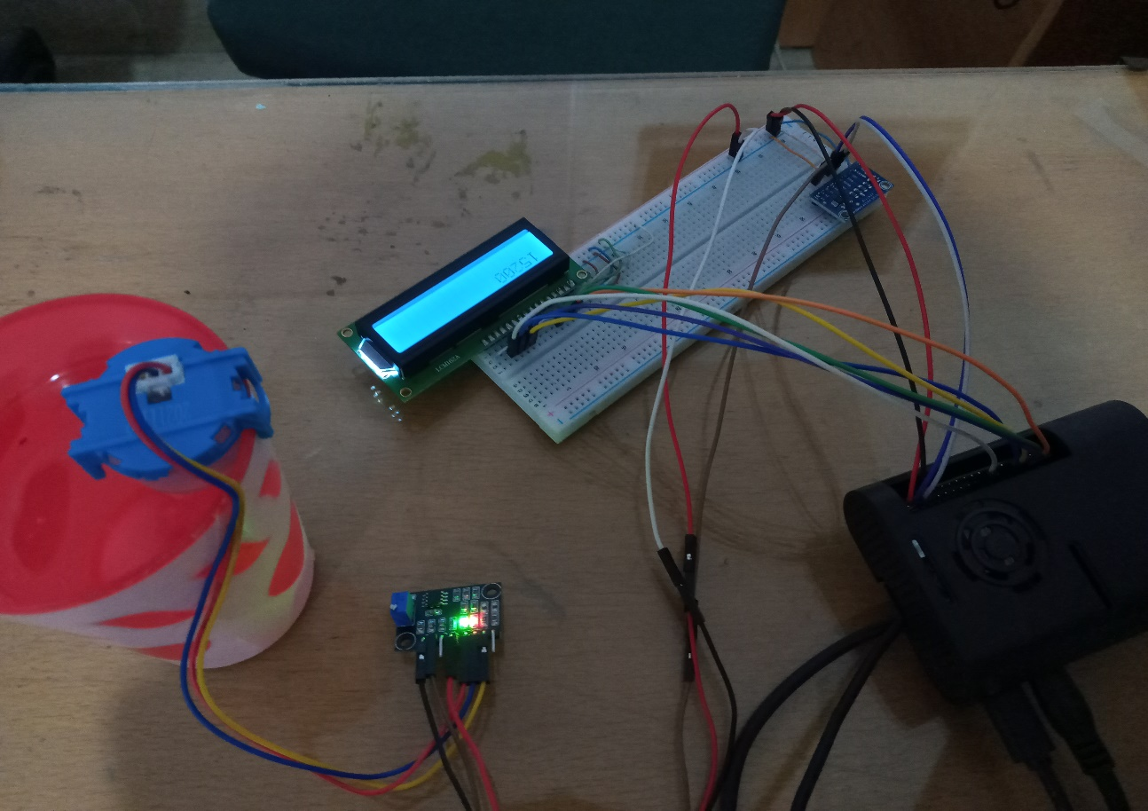

**TDS TESTING**